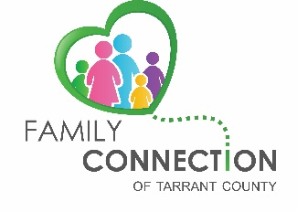

Presents:

Thursday, March 23, 2017

**Treating Youth with Depression and Anxiety in the Context of Family System**

**11:30 a.m. – 1:00 p.m.**

**Cook Children’s Hospital**

**801 7th Ave, Fort Worth, TX 76104**

**PAV CLASS 2 – Free parking vouchers will be given at the workshop**

***You will learn:****What depression and anxiety looks like in youth,*

*How the family system impacts youth’s mental health,*

*And treatment options for optimal outcomes*

*Providers: We encourage you to bring a parent with you, or have a parent who you are working with meet you there. Please help this info get out into our community to families who could benefit from this opportunity.*

**Speaker:** Sam McCage, Psychology and Counseling, licensed as a Marriage and Family Therapist, Professional Counselor, and Chemical Dependency Counselor.

He has been at Cook Children’s for 24 years.

**Brown Bag Lunch**

Please feel free to bring your lunch with you, we will provide drinks.

Tickets: Go one the Eventbrite website and getting a ticket.

Or get your eventbrite ticket on our Facebook page: familyconnectiontc

<https://www.eventbrite.com/e/treating-youth-with-depression-and-anxiety-in-the-context-of-family-system-tickets-32095673022>

  For more info: Valencia Gensollen [familyconnectiontc@gmail.com](mailto:%20familyconnectiontc@gmail.com) 817-881-6451 Childcare is not provided at this time.Family Connection of Tarrant County is a group of parents and others who care about children with mental health struggles. Its vision is to connect and empower families to improve the mental health system in Tarrant County.

Monthly FREE educational workshops are offered around Tarrant County