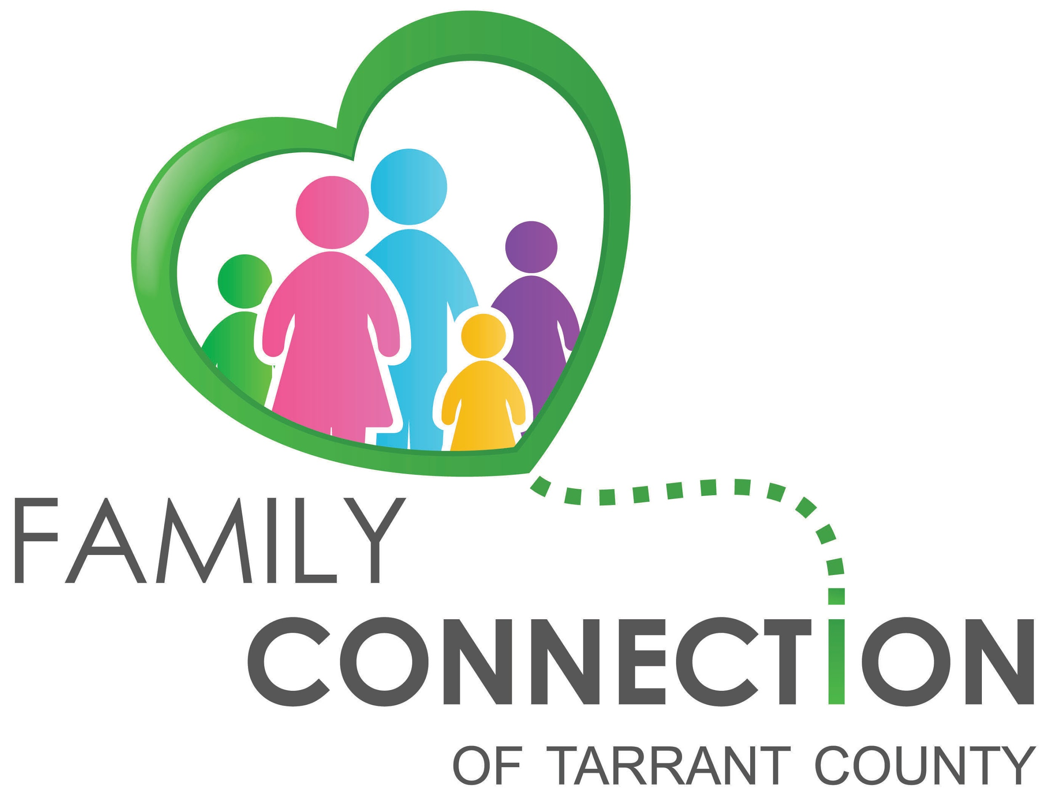

Presents:

**ADHD in Youth and Children**

**Wednesday, Sep 27th 2017**

**10:00am - 11:00am**

**Easter Seals of North Texas - Fort Worth Center**

**Address: 1424 Hemphill St, Fort Worth, TX 76104**

**\*Parking:** Please park either in the street (Feliks Gwozdz), or in the parking lot across the street from the building, “Easterseals Parking Lot B”. Of course, excluding any guests that need to park in the disability parking spaces by the building.

**Please RSVP @** [**familyconnectiontc@gmail.com**](mailto:familyconnectiontc@gmail.com)

**Need help finding the event or info? Call Valencia Gensollen (817) 881-6451**

***You will learn about:***

This workshop will provide an overview of Attention Deficit Hyperactivity Disorder (ADHD) and how parents can obtain additional assistance for their child in the public school setting. The discussion will also include a definition of the types of ADHD, why diagnosis is important, possible causes, and suggestions for helping the child learn new and appropriate behaviors.

Childcare is not provided at this time.

Family Connection of Tarrant County is a group of parents and others who care about children with mental health struggles. Its vision is to connect and empower families to improve the mental health system in Tarrant County. Monthly FREE educational workshops are offered monthly.

For more information:

Valencia Gensollen [familyconnectiontc@gmail.com](mailto:familyconnectiontc@gmail.com) or (817) 881-6451.