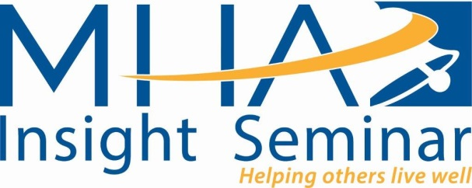

**Please join us on Friday, May 12, 2017 (1p.m. – 4p.m.)**

**Mental Health America of Greater Tarrant County**

**“Look Beneath the Surface: Recognizing Victims of Human Trafficking”**

**Sarolyn Morgan LCSW-S, BCD**

**Sarolyn Morgan** is a Licensed Clinical Social Worker Supervisor with a Board Certified Diplomat (LCSW-S, BCD). She has been the Victim Assistance Specialist for Homeland Security Immigration and Customs Enforcements (HIS-ICE) since October 2016. She has served victims of traumatic events officially since 1995. She also currently serves in the United States Army Reserves as the Sexual Harassment Assault Response Prevention (SHARP) and Suicide Prevention Clinical Subject Matter Expert (SME) for the 807th Medical Command Deployment Support since 1998. In January she will have 27 years of military services, which is includes 8 years of active duty and the remaining years as a Reserve Soldier. She is an ASIST (Applied Suicide Intervention Skills Training) Coach for Living Works and provides some psychotherapy services in the community. Some of Mrs. Morgan jobs include work the Suicide prevention Coordinator and MST psychotherapist for the Department of Veteran’s Affairs, The United States Army (Suicide Prevention Program Manager/SHARP PM), Private Practice treatment PTSD and Sexual Trauma for 12 years, Alliance for Children as a Sexual Trauma Therapist, the Federal Bureau of Prisons as a Drug Treatment Specialist and Child Protective Services. She and her husband of 20 years have two teenage boys (16 and 17 years old) and their favorite pet, Tyson.

**Learning Objectives**:

1. Rights of victims under TVPA
2. Intersections of Domestic Violence and Human Trafficking
3. Behavioral Factors
4. Social Media

The fee for this **3-hour CEU seminar** is $50 for non-MHA members, $40 for MHA members and $20 for students.Registration deadline (online/by mail) **must be received** by April 11, 2017

1) Mail check to MHA at 3136 W. 4th Street, Ft. Worth, TX, 76107; fax number: 817-810-3230

2) Online at www.[Eventbrite](https://www.eventbrite.com/e/human-trafficking-sarolyn-morgan-lcsw-s-bcd-tickets-34423591890).com

MHA is an approved provider of continuing education in Texas for LPC with approval #1099, Social Workers #5467, and LMFT #419.

For additional information, please contact Barbara Jordan at 817-569-5779 / [Barbara.Jordan@mhmrtc.org](mailto:Barbara.Jordan@mhmrtc.org) or Deannah Rowell at 817-569-5780 / [Deannah.Rowell@mhmrtc.org](mailto:Deannah.Rowell@mhmrtc.org)

**Registration by Mail (print off and send with check or credit card payment to MHA)**

NAME:

ADDRESS:

CITY, STATE, ZIP:

HM/CELL PHONE: ________________________________WK PHONE:

E-MAIL:

PAYMENT METHOD _____VISA_____MC______AMEX______DISCOVER_____CHECK ENCLOSED

CREDIT CARD NUMBER________________________________________EXP. DATE____________

SECURITY CODE: ___________________ TOTAL AMOUNT ENCLOSED: $__________________