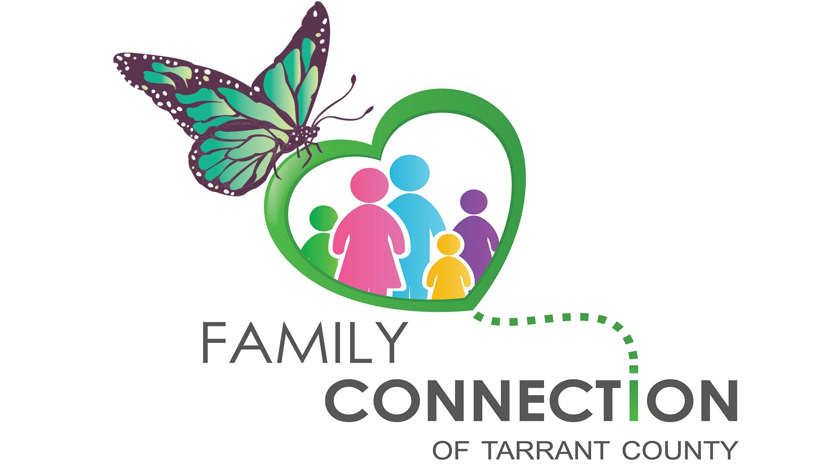

Presents:

**Reaching Teens Training for Parents -The Impact of Trauma on the Development and Well-Being**

**Thursday, May 18, 2017**

**Evening Workshop: 6:30 PM to 8:00 PM**

**Travis Avenue Baptist Church**

**775 W Berry St. Fort Worth, TX 76110**

**\*Enter at the Welcome Center Look for the Family Connection Sign and Call if you need help finding event (817) 881-6451**

Workshop info: *The numbers of youth exposed to overwhelming events during critical developmental periods is astonishingly high and requires us to take a public health approach that focuses on addressing the problems of the young people who have already been affected by traumatic events, building in resiliency skills for those already affected at risk, and educating everyone.*

**Speaker:** James Spivey

**Tickets: Facebook:** <https://www.facebook.com/events/643470412530981>

**Eventbrite:** https://www.eventbrite.com/e/reaching-teens-training-for-parents-the-impact-of-trauma-tickets-34429144498

Childcare is not provided at this time.

Family Connection of Tarrant County is a group of parents and others who care about children with mental health struggles. Its vision is to connect and empower families to improve the mental health system in Tarrant County. Monthly FREE educational workshops are offered around Tarrant County

Family Connection familyconnectiontc@gmail.com (817) 881-6451