

# FOR EDUCATORS, SOCIAL WORKERS & HEALTH CARE PROVIDERS

FR EE

MOVIE

S CR EEN I NG

**APRIL 24 2018 • 5:30PM – 8:30PM**

# UTA SCHOOL OF SOCIAL WORK COMPLEX AUDITORIUM

## FREE POPCORN SODA

**Q&A SESSION FOLLOWS**

**0.3**

## SSW CEU

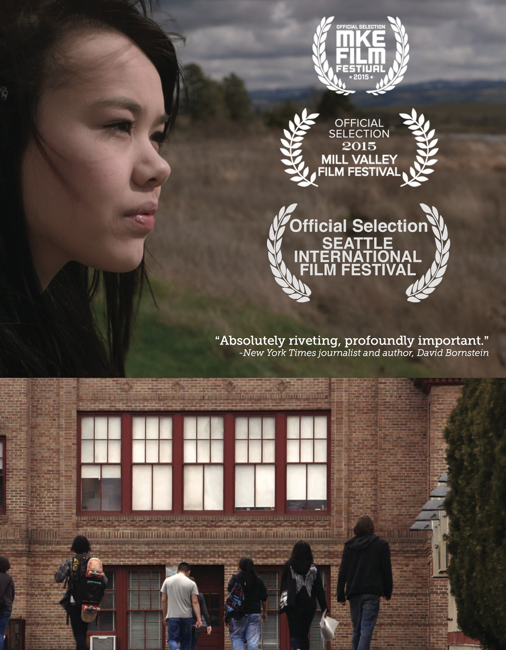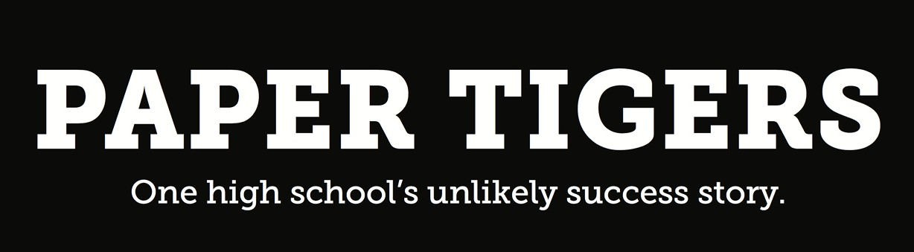

UNIVERSITY OF TEXAS AT ARLINGTON • SCHOOL OF SOCIAL WORK • 211 S COOPER STREET, ARLINGTON, TX 76019