A health and lifestyle expo event for boomers, seniors and caregivers!

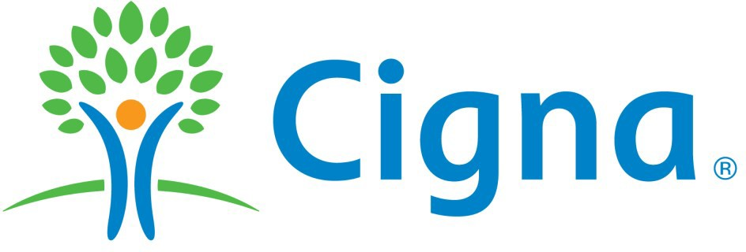
Title Sponsor
6th Annual




Platinum Sponsor
Thursday, May 3, 2018
8:30 a.m. - 1:30 p.m.
Platinum Sponsor


Tarrant County Judge Glen Whitley and Cigna invite you to the 2018 Senior Synergy Expo. Come learn about the services available in Tarrant County that will empower boomers, seniors and caregivers to live a healthier lifestyle.
FREE: Admission ● Health Screenings ● Workshops ● Parking ● Lunch*

To attend the EXPO, register today at:
/817-884-1234
klrotter@tarrantcounty.com
*Must register before April 23rd to guarantee lunch.

Will Rogers – Amon G. Carter Jr. Exhibits Hall 3400 Burnett-Tandy Drive
Fort Worth, TX 76107

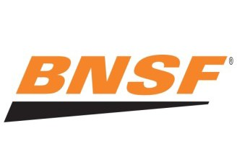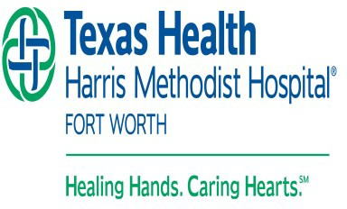

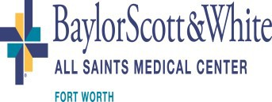


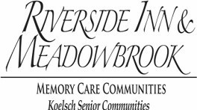
AARP ● Blue Cross Blue Shield ● Ciera Bank ● Fort Worth Black News ● HealthSouth ● Home Instead Senior Care ● ITG Insurance Klarus Home Care ● Mayhill Hospital ● MHMR of Tarrant County ● ONCOR Electric ● Outreach Health Services ● Performing Ads Sports and Wellness ● United Way Area Agency on Aging ● Walgreens ● Assisted Services, Inc. ● Blue Zones Project ● Chrys Jones, Attorney at Law, PLLC ● Courtyards at River Park ● Dan Dipert Tours & Coaches ● Dignity Memorial ● Emerald Hills Funeral Home Fort Worth Transportation Authority ● Greenfield Senior Living ● Home Care Assistance ● Lakewood Village Senior Living ● Lion’s Club District 2E2 ● Lucas Family Funeral Homes ● MedStar ● Senior Downsizing Experts ● SilverSneakers ● United Healthcare
Ventamatic Ltd. ● VITAS Healthcare of Texas
Knowledge is power, come learn about services available for you to live a
healthier and independent lifestyle.

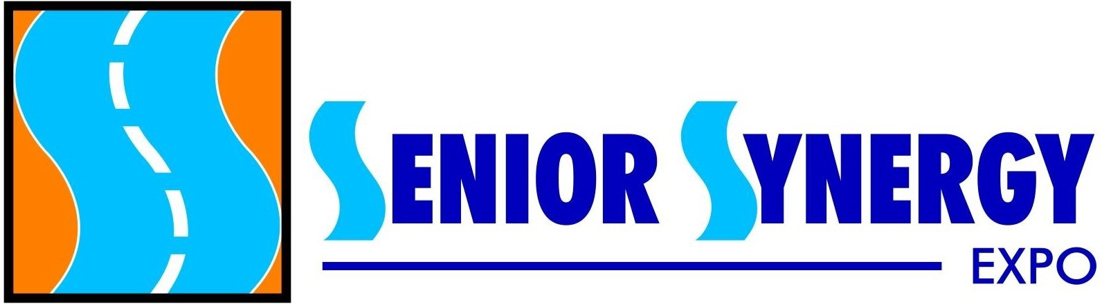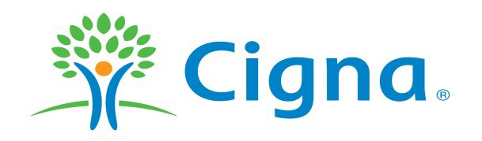
6th Annual
Thursday, May 3, 2018
8:30 a.m. - 1:30 p.m.
2018 Title Sponsor

(Information collected will not be shared, distributed or used for any purpose other than Senior Synergy Expo)
Will Rogers - Amon G. Carter Jr. Exhibits Hall
3400 Burnet-Tandy Drive, Fort Worth, Texas 76107
Senior Synergy Expo is a health and lifestyle event for boomers, seniors and caregivers! Register by completing this form or online at
www.SeniorSynergyExpo.com.
Attendee Registration
CUT HERE
Please Print Clearly

Name: Address: City/State/Zip: Phone: Email: Circle your age: 18-24 25-34 35-44 45-54 55-64 65-74 75+
If applicable, what is the name of your group association? (e.g. church name, senior center name, YMCA, etc.)

How did you hear about the event? Friend Seniorific News Family Member Star-Telegram Senior Center TAGs Radio/TV Church/Synagogue Library Neighborhood Assoc. Other
Have you attended the Expo in the past? Yes No
If “YES”, check the previous year(s) attended: 2013 2014 2015 2016 2017

Send the completed form to

Kathryn Rotter via the following options:
MAIL: Tarrant County Judge Glen Whitley 100 E. Weatherford Street, Suite 501 Fort Worth, TX 76196
FAX: 817-884-2793
EMAIL: klrotter@tarrantcounty.com
For more information call 817-884-1234
To guarantee FREE box lunch
& FREE parking, registration form must be received no later than Monday, April 23, 2018

